Real-Time Windows Security Log Monitoring Using Splunk SIEM

Project Overview
This project demonstrates real-time Windows Event Log monitoring using Splunk Enterprise and Splunk Universal Forwarder.
Windows logs are collected from a Windows system and forwarded to Splunk Enterprise running on Kali Linux. The logs are analyzed using Splunk searches, dashboards, and alerts.
The project helps understand SIEM (Security Information and Event Management), log analysis, and real-time security monitoring.
Technologies Used
- Splunk Enterprise
- Splunk Universal Forwarder
- Windows 10/11
- Kali Linux
- Windows Event Logs
Project Objective
The main objective of this project is to collect, monitor, and analyze Windows Event Logs in real time using Splunk SIEM.
The project helps detect:
- Failed login attempts
- Successful logins
- Security events
- System activities
- Suspicious behavior

System Architecture
Windows Machine
↓
Splunk Universal Forwarder
↓
Splunk Enterprise (Kali Linux)
↓
Log Monitoring & Analysis
Features
- Real-time Windows log monitoring
- Security event analysis
- Failed login detection
- Successful login monitoring
- Dashboard visualization
- Alert creation
- Centralized log management
Installation and Configuration
1. Install Splunk Enterprise on Kali Linux
Download and install Splunk Enterprise.
"https://download.splunk.com/products/splunk/releases/10.0.2/linux/splunk-10.0.2e2d18b4767e9-linux-amd64.deb"
Install:
sudo dpkg -i splunk.deb
Start Splunk:
bash
sudo /opt/splunk/bin/splunk start --accept-license --answer-yes --no-prompt --run-as-root
./splunk start
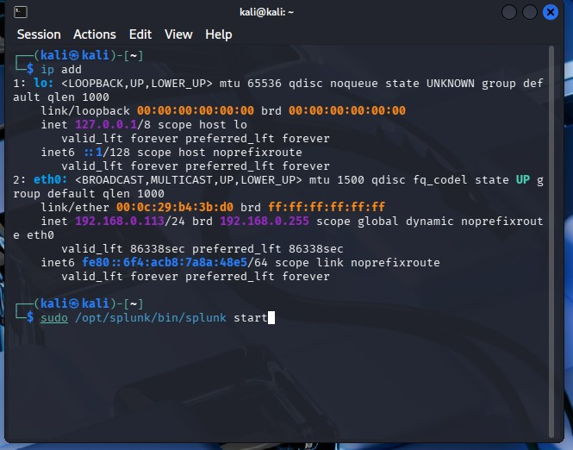

Open Splunk dashboard:

http://127.0.0.1:8000
2. Enable Receiving Port
Enable port 9997 in Splunk Enterprise:
bash
sudo /opt/splunk/bin/splunk enable listen 9997 --accept-license --answer-yes --no-prompt --run-as-root
Restart Splunk:
bash
sudo /opt/splunk/bin/splunk restart --run-as-root
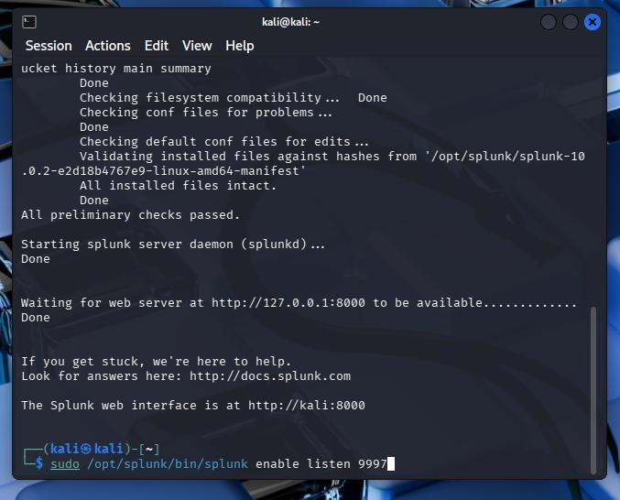
3. Install Splunk Universal Forwarder on Windows
Download Splunk Universal Forwarder and install it on Windows.
During installation:
- Leave Deployment Server blank
- Enter Receiving Indexer:
Kali-IP:9997
Example:
192.168.1.5:9997
4. Configure Windows Event Logs
Open:
C:\Program Files\SplunkUniversalForwarder\etc\system\local\inputs.conf
Add: Notepad
[WinEventLog://Application]
disabled = 0
[WinEventLog://Security]
disabled = 0
[WinEventLog://System]
disabled = 0
Save the file and restart Splunk Forwarder service.
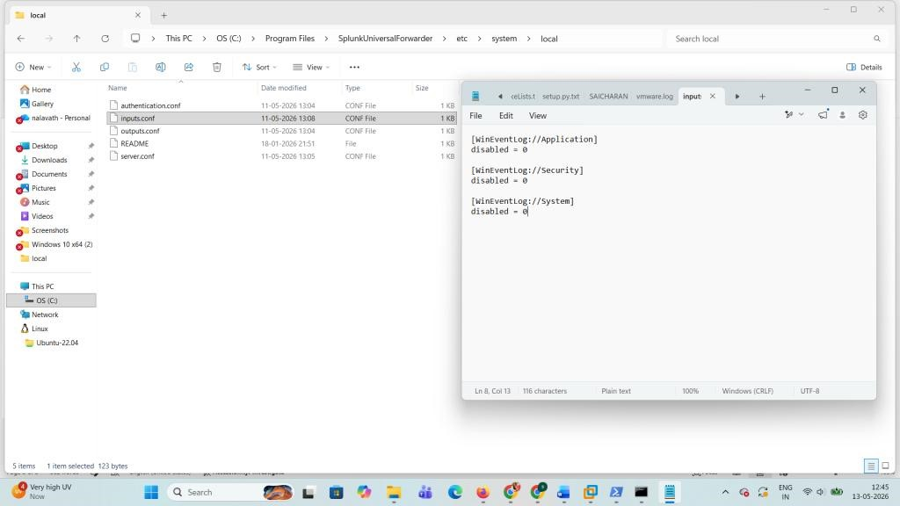

5. In the Windows Power shell Restart Forwarder
net stop splunkforwarder net start splunkforwarder
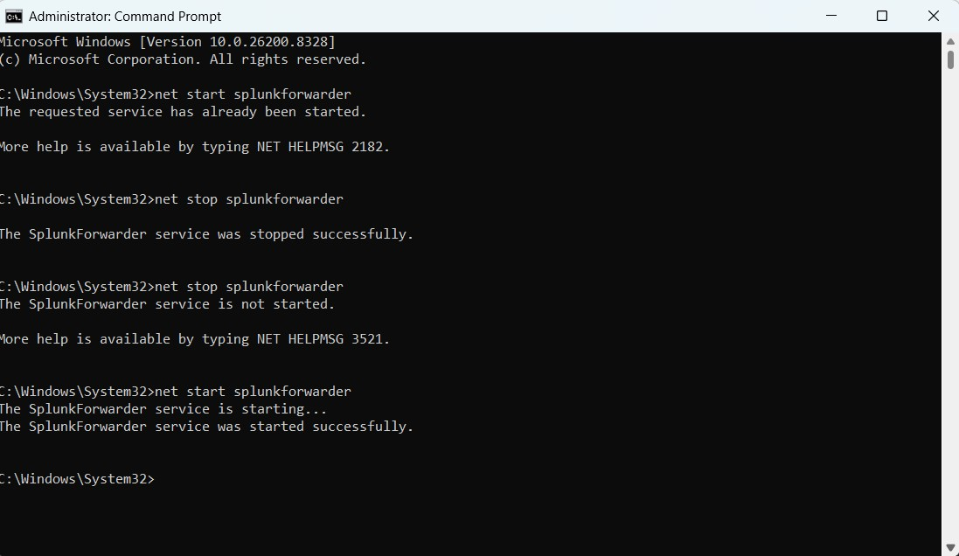
Splunk Queries Used
Show All Logs
spl
index=main
Show Security Logs
spl
source="WinEventLog:Security"
Failed Login Attempts
spl
EventCode=4625
Successful Logins
spl
EventCode=4624
System Logs
spl
source="WinEventLog:System"
Application Logs
spl
source="WinEventLog:Application"
Detect Multiple Failed Logins
spl
EventCode=4625
| stats count by Account_Name
| where count > 5
Dashboard Panels
The dashboard includes:
- Failed Login Attempts
- Successful Logins
- Top Users
- System Errors
- Real-Time Monitoring
Alerts
Security alerts can be created for:
- Multiple failed login attempts
- Suspicious activities
- Account lockouts
- Security event monitoring

Result
The project successfully collected and monitored Windows Event Logs using Splunk Enterprise and Splunk Universal Forwarder.
Real-time monitoring, log analysis, dashboard visualization, and security event detection were successfully implemented.
Learning Outcomes
- SIEM fundamentals
- Splunk administration
- Log analysis
- Security monitoring
- Dashboard creation
- Alert management
- Windows Event Log analysis
Future Enhancements
- Email alert notifications
- Malware monitoring
- PowerShell activity monitoring
- Multiple system monitoring
- Advanced dashboards
- Threat detection
Screenshots
Add screenshots of:
Splunk Dashboard
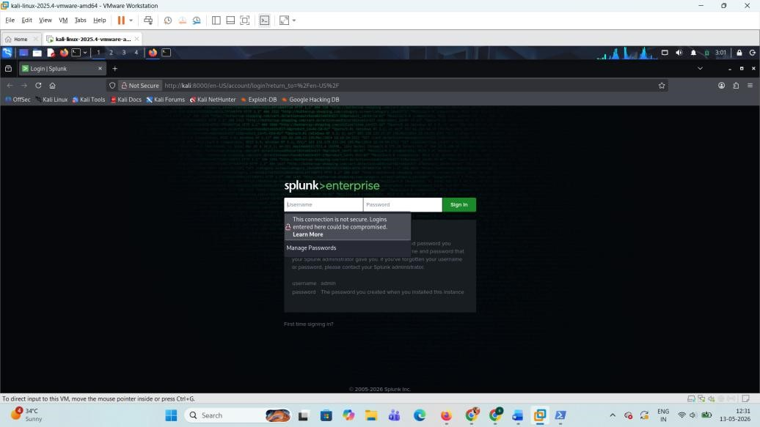

Search & Reporting
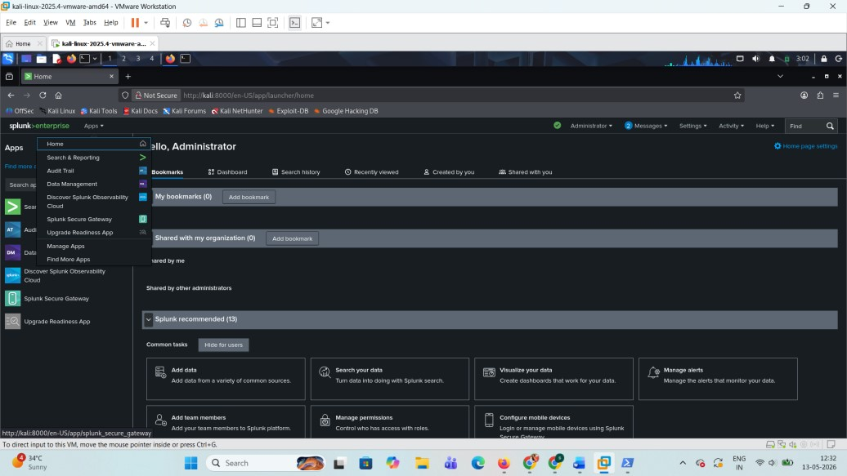
Windows Security Logs
Index=main
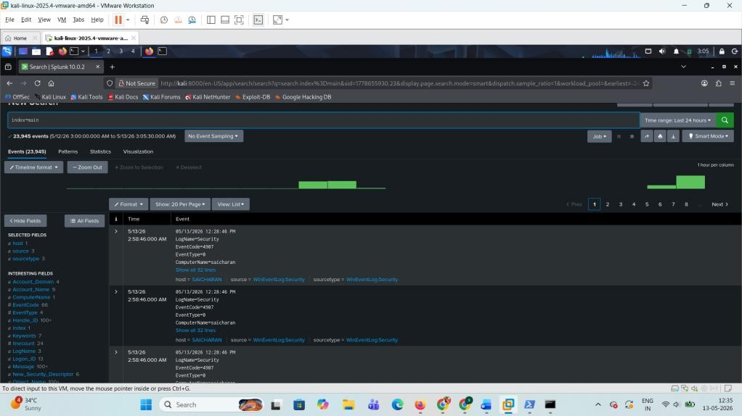
- Real-Time Monitoring
Applications
This project can be used in:
- Security Operations Centers (SOC)
- Cybersecurity monitoring
- Enterprise log management
- Security auditing
- Incident detection
Conclusion
This project demonstrates how Splunk SIEM can be used to collect, monitor, and analyze Windows logs in real time
The implementation helps understand SIEM, SOC monitoring, and cybersecurity log analysis concepts.
Author
Ruchith
Cybersecurity & SIEM Enthusiast

